DISCLAIMER, TERMS OF USE, AND LIMITATION OF LIABILITY

PLEASE READ THIS DISCLAIMER CAREFULLY BEFORE USING THIS DOCUMENT.

PURPOSE AND SCOPE
This Incident Response Cheat Sheet ("Document") is provided solely for general educational and informational purposes. It is intended as a quick-reference guide to assist organizations in developing their incident response capabilities and is designed to supplement—not replace—comprehensive cybersecurity programs, formal training, professional services, or legal counsel.

NO PROFESSIONAL ADVICE
Nothing in this Document constitutes professional cybersecurity, legal, regulatory, or business advice. The information provided is general in nature and may not be applicable to your specific circumstances, industry, jurisdiction, or regulatory environment. Organizations subject to specific compliance requirements (including but not limited to HIPAA, PCI-DSS, GDPR, CCPA, SOX, or industry-specific regulations) should consult qualified professionals to ensure compliance.

NO WARRANTY
THIS DOCUMENT IS PROVIDED "AS IS" AND "AS AVAILABLE" WITHOUT ANY WARRANTIES OF ANY KIND, EITHER EXPRESS OR IMPLIED. THE AUTHORS AND DISTRIBUTORS EXPRESSLY DISCLAIM ALL WARRANTIES, INCLUDING BUT NOT LIMITED TO IMPLIED WARRANTIES OF MERCHANTABILITY, FITNESS FOR A PARTICULAR PURPOSE, ACCURACY, COMPLETENESS, AND NON-INFRINGEMENT.

No representation is made that the information in this Document is accurate, complete, current, or error-free. Cybersecurity threats, technologies, and best practices evolve continuously, and this Document may not reflect the most current developments.

LIMITATION OF LIABILITY
TO THE FULLEST EXTENT PERMITTED BY APPLICABLE LAW, IN NO EVENT SHALL THE AUTHORS, DISTRIBUTORS, OR CONTRIBUTORS BE LIABLE FOR ANY DIRECT, INDIRECT, INCIDENTAL, SPECIAL, CONSEQUENTIAL, PUNITIVE, OR EXEMPLARY DAMAGES (INCLUDING BUT NOT LIMITED TO DAMAGES FOR LOSS OF PROFITS, BUSINESS INTERRUPTION, LOSS OF DATA, OR OTHER INTANGIBLE LOSSES) ARISING OUT OF OR IN CONNECTION WITH THE USE, INABILITY TO USE, OR RELIANCE ON THIS DOCUMENT, EVEN IF ADVISED OF THE POSSIBILITY OF SUCH DAMAGES.

ASSUMPTION OF RISK
By using this Document, you acknowledge and agree that:
- You assume all risks associated with the use of this information
- You are solely responsible for determining the appropriateness of using this Document for your organization
- You will seek qualified professional assistance for actual security incidents
- You will customize any guidance to your organization's specific needs and environment
- You will maintain appropriate cybersecurity insurance and incident response retainers

INDEMNIFICATION
You agree to indemnify and hold harmless the authors and distributors from any claims, damages, or expenses arising from your use of this Document.

NO PROFESSIONAL RELATIONSHIP
Use of this Document does not create any professional-client, attorney-client, or consulting relationship between you and the authors or distributors.

GOVERNING LAW
Any disputes arising from the use of this Document shall be governed by applicable law in your jurisdiction.

ACKNOWLEDGMENT
By using this Document, you acknowledge that you have read, understood, and agree to be bound by these terms.

──────────────────────────────────────────

For actual cybersecurity incidents, always engage qualified incident response professionals and legal counsel.

Last Updated: January 9, 2026

INCIDENT RESPONSE CHEAT SHEET
For Small & Medium Businesses
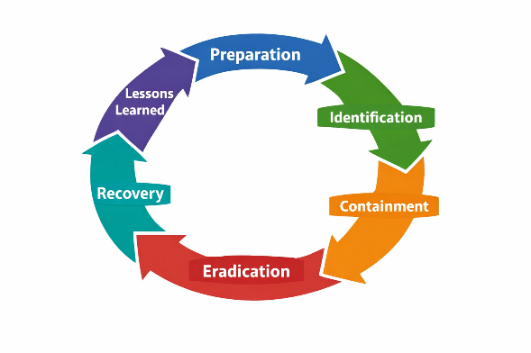
📋 PRE-GAME CHECKLIST
Complete these BEFORE an incident occurs
- Do you have documented baselines for normal system/network behavior?
- Do you have tested, offline backups?
- Are logs being collected and stored securely?
- Are you collecting the RIGHT logs? (auth, firewall, endpoint, critical apps)
- Do you have an asset inventory?
- Is there a communication plan for incidents?
- Do employees know who to contact if they see something suspicious?
🔄 THE 6 PHASES

1. PREPARATION
- Is the IR plan documented and accessible?
- Does everyone know their role?
- When was the last tabletop exercise or drill?

2. IDENTIFICATION
- What triggered the alert? (user report, automated alert, external notification)
- What systems/data are potentially affected?
- What is the scope? (single machine, network segment, entire org)

3. CONTAINMENT
- Has the affected system been isolated from the network?
- Are backups protected from compromise?
- Has the attacker's access been cut off without tipping them off?

4. ERADICATION
- How did you confirm the threat is fully removed?
- Were all attacker footholds identified? (backdoors, accounts, persistence)
- Is enhanced monitoring in place for reinfection?

5. RECOVERY
- Has the system been rebuilt/restored from clean source?
- Are patches and hardening applied before reconnecting?
- Is there a monitoring plan for the first 48-72 hours?

6. LESSONS LEARNED
- What worked well? What failed?
- What changes need to be made to prevent recurrence?
- Has the IR plan been updated with findings?
🚨 SEVERITY LEVELS
⚠️ Rule: If you can't determine severity within the triage window, escalate to the next level up.
💡 "Unknown" defaults to HIGH until proven otherwise.
Level | Description | Example | Triage | Response
CRITICAL | Business halted, breach confirmed | Ransomware, active exfiltration | Immediate | All hands
HIGH | System compromised, potential exposure | Malware on server, admin account compromised | 15 min | Within 1 hour
MEDIUM | Suspicious activity, no confirmed compromise | Phishing clicked, unusual login | 30 min | Within 4 hours
LOW | Minor event, low risk | Failed logins, policy violation | 1 hour | Within 24 hours
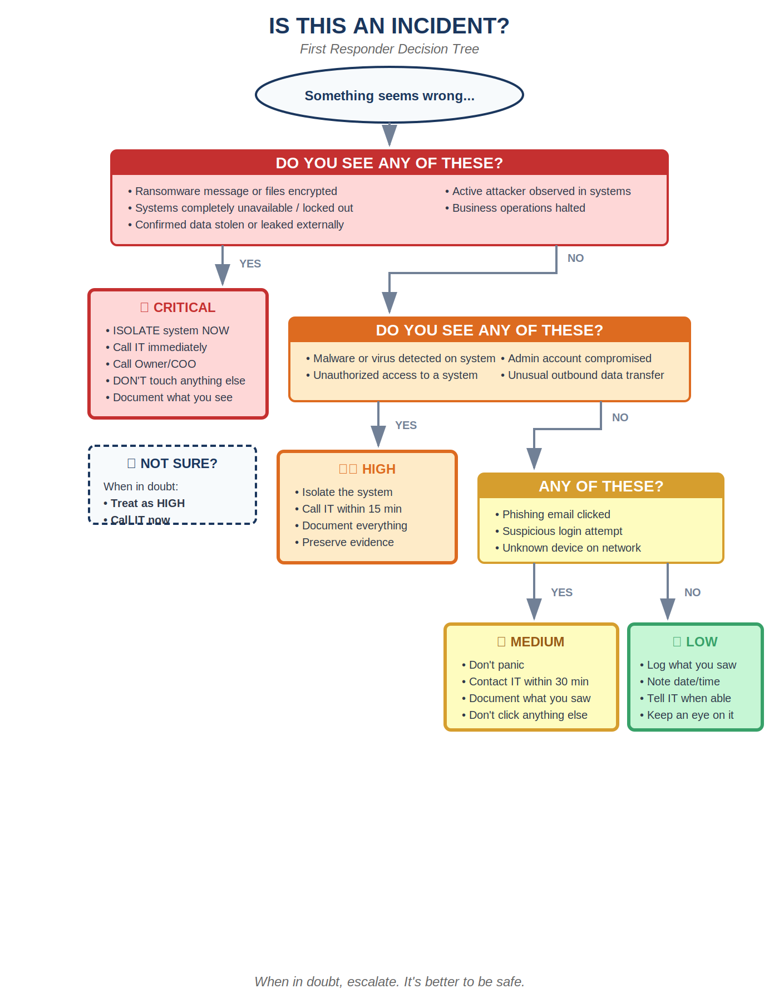

🔴 IMMEDIATE DO / DON'T LIST
For the first responder - read this first!

✅ DO  - Document everything with timestamps  - Take photos/screenshots before touching anything (Consider sensitivity of data)  - Isolate affected systems (unplug network, NOT power)  - Preserve logs and evidence  - Call your contacts list | ❌ DON'T  - Shut down systems (destroys RAM evidence)  - Try to "fix it quick" before documenting  - Communicate over compromised systems  - Publicly announce before legal approval  - Delete anything

📞 EMERGENCY CONTACTS

Role | Name | Phone | Email
IT Lead / Sysadmin
Business Operations
Owner / COO / Decision Maker
IT Contractor / MSP
Legal Counsel

📄 QUICK DOCUMENTATION TEMPLATE
Fill this out during the incident - print multiple copies

Incident Date/Time Discovered: ________________________________
Reported By: ________________________________
Affected System(s): ________________________________
How was it detected?: ________________________________
Initial Severity: ☐ Critical ☐ High ☐ Medium ☐ Low
Brief Description:
_____________________________________________________________
_____________________________________________________________
Actions Taken (with timestamps):
1. ___________________________________________________________
2. ___________________________________________________________
3. ___________________________________________________________
Who has been notified?: ☐ IT Lead ☐ Owner/COO ☐ Legal ☐ Insurance ☐ Contractor

Share freely. Adapt for your organization.
Licensed under Creative Commons Attribution 4.0 (CC BY 4.0)

